
A Project SUBMITTED TO
Developed by : Your Name

NOBLE UNIVERSITY

Submitted in partial fulfillment of the requirements for the degree of

Bachelor of Computer

SUBMITTED BY

“Sanghavi Karan” Enrollment No: 240431210

Faculty of I.M.C.A. / BCA

1

PREFACE
There is a wide difference between theory and practical. If one has only theoretical background of any subject, one would not succeed in own aim therefore it is necessary for any person to have acceptable practical knowledge of the concerned subject. As I know BCA is a course based on “Information Technology” and it is totally practical field. With only theoretical knowledge one can’t be succeeded or one can’t be on the peak position.
In the course of IMCA/BCA designed by the “Noble University” they have taken full care of these things and designed the course in such a manor with which student can get theoretical and practical both type of knowledge perfectly. According to the rules & regulation of “Web Development”, I have a subject named “Vimal Agency”. In which we have to create a web project of any institute or industry.
As a IMCA/BCA student, I have gathered general information about Whole Admission Process. Then I decided to develop the site for that. In this site you can start admission to any collage very easily. You can also put the advertisement on this site.
In this project report I have covered all the information, which is required for the web project of IMCA/BCA student.
I have tried as my best to present this project report in such a way that it makes easy to understand the project work.

2

ACKNOWLEDGEMENT
Developed by : Your Name

I am thankful to all, who have helped me in preparing this project. I am very much happy to present this “Project Report”. Before you, expecting that you will acknowledgement it. It is a matter of great pleasure for me that I had an opportunity to express my view on the same.
As a part of my academic study as the student of 5th semester of IMCA/BCA I am required to experienced training software project an institute or industry in order to obtain practical knowledge and broaden me regarding the same.
At first, I would like to express my& humble thanks & gratitude to the who has provided me such a great, Co-operative & progressive environment.
Secondly at this moment, I would like to express my deepest sense of gratitude to my professor as well as project guidance who have contributed their precious time for the purpose of giving me the correct information with special interest & guidance throughout my project work.
I am also thankful to my classmate and few others who helped me directly or indirectly in solving problem & in making my software project more efficient & good working.

3

INDEX
Developed by : Your Name

Ch. no. | Title | Page No.
1 | Introduction and object of project
2 | Tools or platform
3 | User interface
4 | Coding
5 | Testing

4

Developed by : Your Name

Chapter – 1 Introduction and Object of Project
INTRODUCTION

This project is specially designed for Students, because in this project Students Can Find online best Colleges and Courses and also can registered as a User in this project “College Management System”.
Students can place their inquiry for any Particular College and Course through our project “College Management System”.
The “College Management System” project is a multi-user
system.
It has been developed in a way that allows user to perform the
function smoothly and with proper accuracy.
The system is developed in HTML, CSS, Java script and some other software for designing purpose.
So, this system is very useful for all types of Students.

5

Developed by : Your Name

HOW IT WORKS

In this project first of all a homepage is displayed for all visitor, Students as well as registered Students.
This page will give information about College Management System details etc.
If user wants to place their inquiry, then they have to Login first. If the user is not a Registered User, He / She will have to click on the Signup Button and fill all fields in the registration form.
After registering in “College Management System”there you can see login button.
Users will have to login with registered mobile number and
password.
After login, user will see User-Panel of “College
Management System” Website.
There is various information about colleges, courses, inquiry
and etc.

6

Developed by : Your Name

Chapter – 2 Tools or Platform

Requirements Details

- SOFTWARE: -
- Any Browser Like (Google Chrome, Internet Explorer, Mozilla etc.)

  - HARDWARE: -
- Processor: P3 or higher
- RAM: 512 MB or higher
- Hard Disk: 50 GB or higher

  - TOOLS USED: -
- Front End: HTML, CSS, JavaScript
- Operating System: Windows 7 or higher

7

Developed by : Your Name

3 - PROJECT PLANNING

No. | Task Name | Start | Finish | Duration
1. | Planning | 15-July | 23-July | 1 Week
2 | Analysis | 25-July | 30-July | 2.1 Week
3 | Designing | 1-Aug | 10-Aug | 2.5 Week
4 | Coding | 15-Aug | 2-Sep | 3.5 Week
5 | Implementation | 5-Sep | 10-Sep | 1 Week
6 | Testing | 11-Sep | 15-Sep | 1.1 Week
 | TOTAL |  |  | 62 DAYS

8

Developed by : Your Name
3.1 - SOFTWARE REQUIREMENT

JAVA Script: -

- JAVA SCRIPT ORIGINS: -

  - JavaScript was released by Netscape and Sun Microsystems in 1995.
  - However, JavaScript is not the same thing as Java. o It is a programming language. o It is an interpreted language. o It is object- based programming. o It is widely used and supported o It is accessible to the beginner.

- USES OF JAVA SCRIPT: -

  - Use it to add multimedia elements with JavaScript you can show, hide, change, resize images, and create image rollovers. You can create scrolling text across the status bar.
  - Create pages dynamically Based on the user's choices, the date, or other external data, JavaScript can produce pages that are customized to the user.

9

Developed by : Your Name

HTML: -

- HTML is the standard Mark-up language for creating web pages and CSS and JavaScript it forms a triad of cornerstone technologies for the WWW.
- Web browsers receive HTML documents from a web server or from local storage and render them into multimedia web pages.
- HTML describes the structure of a web page semantically and originally included cues for the appearance of the document.
- Hyper Text Mark-up Language (HTML) can embed programs written in a scripting language such as JavaScript which affect the behavior and content of web pages.
- Inclusion of CSS defines the look and layout of content. The World Wide Web consortium (W3C), maintainer of both the HTML and the CSS standards, has encouraged the use of CSS over explicit presentational HTML since 1997.

10

Developed by : Your Name

CSS: -

  - Cascading Style Sheet (CSS) is a Style sheet language used for describing the presentation of a document written in a Mark-up language. Although most often used to set the visual style of web pages and user interfaces written in HTML and XHTML, the language can be applied to any XML document, including plain XML, SVG and XUL, and is applicable to rendering in speech, or on other media. Along with HTML and JavaScript, CSS is a cornerstone technology used by most websites to create visually engaging web pages, user interfaces for web applications, and user interfaces for many mobile applications.
  - CSS is designed primarily to enable the separation of presentation and content, including aspects such as the layout, colors, and fonts.

11

Developed by : Your Name
Use Case Diagrams:

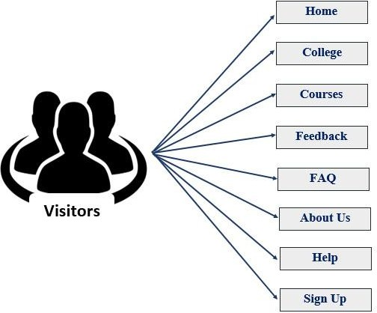

12

Developed by : Your Name

Chapter – 4
User Interface

13

Developed by : Your Name

- Visitor Side Screenshots: -

  - Index Page:

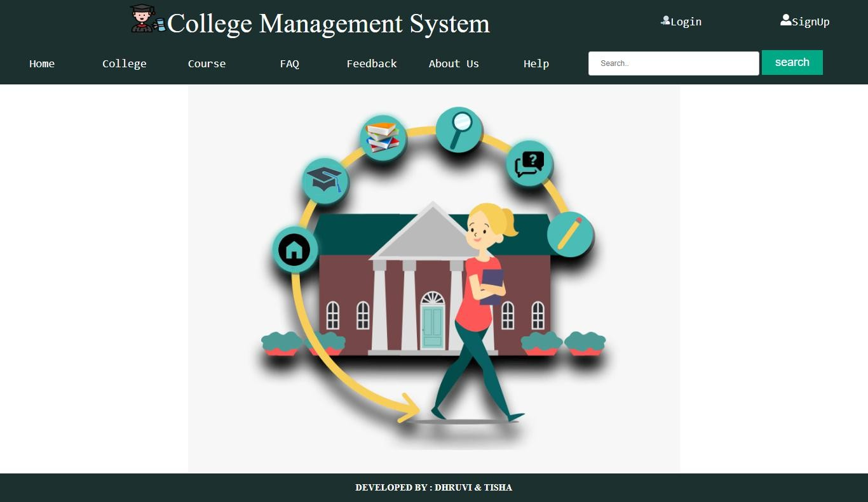

14

Developed by : Your Name
  - Sign Up Form:
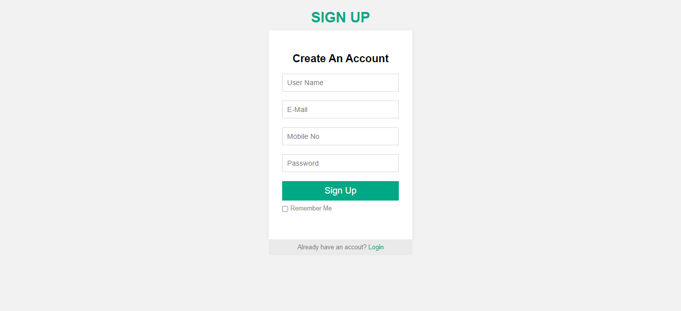

  - Login Form:
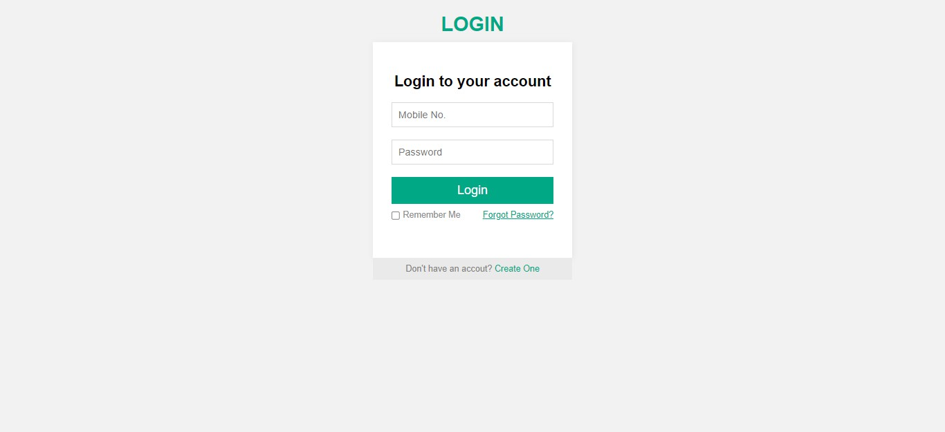

15

Developed by : Your Name
  - College Display Page:
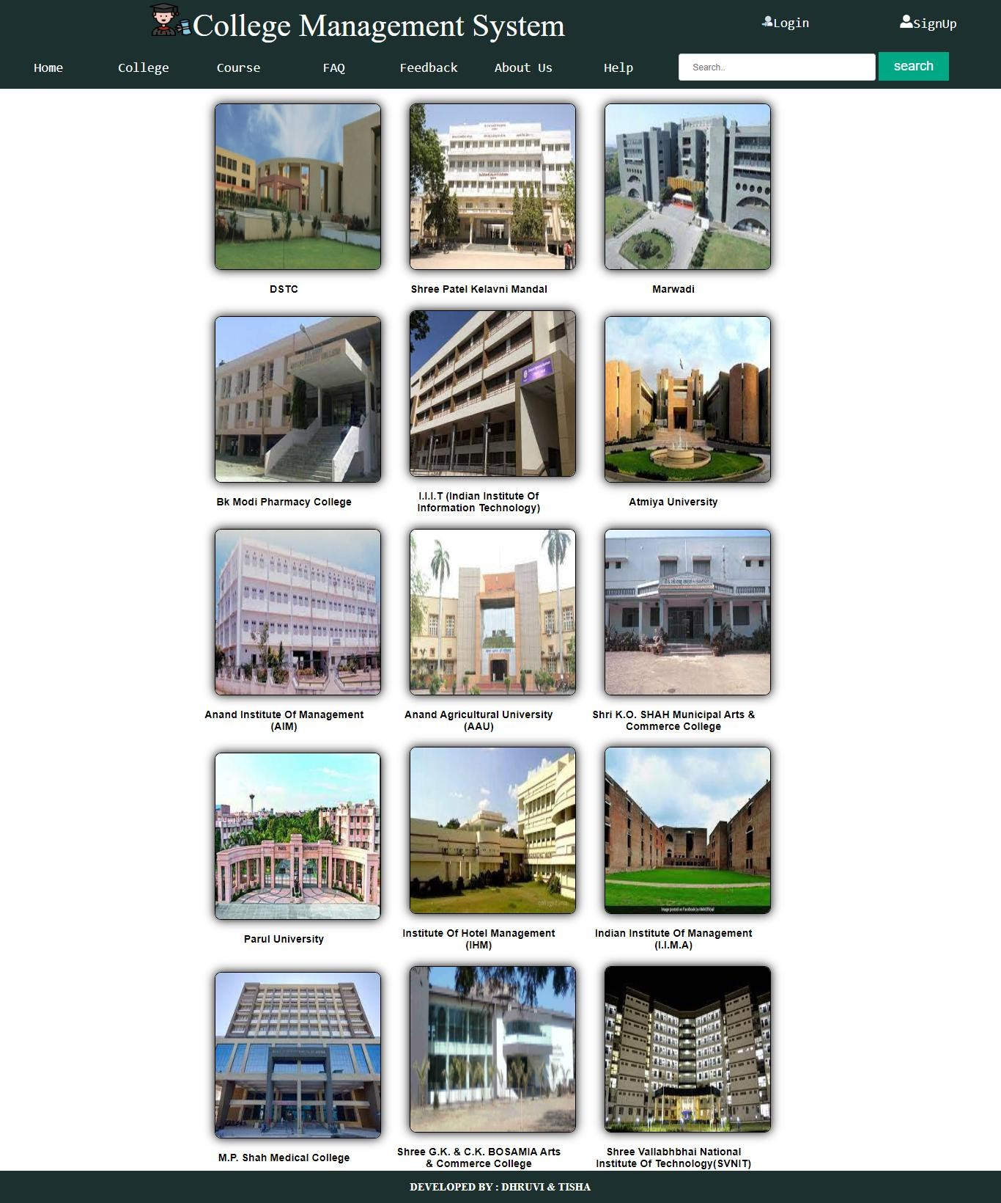
  - College Information Page:
16

Developed by : Your Name

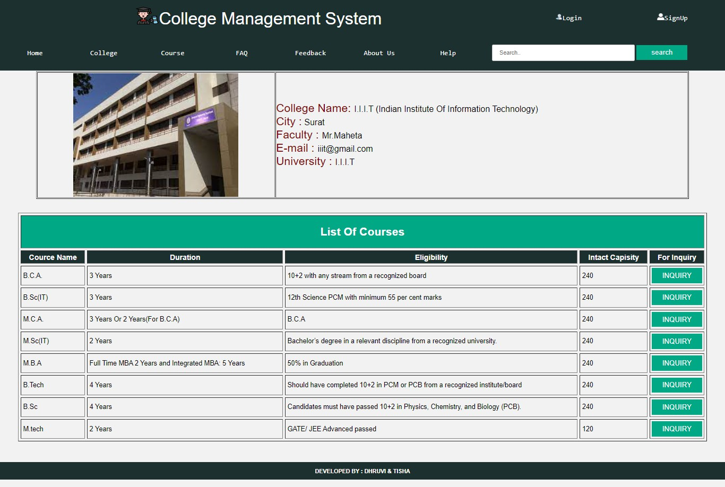

17

Developed by : Your Name
  - Course Page:

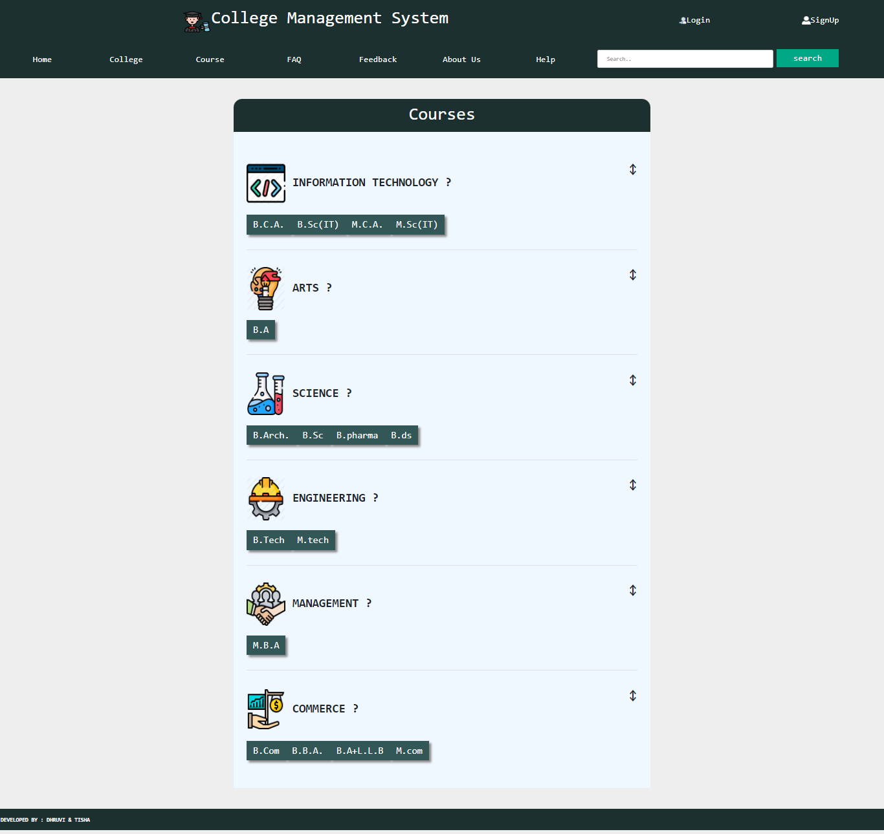

18

  - FAQ:
Developed by : Your Name

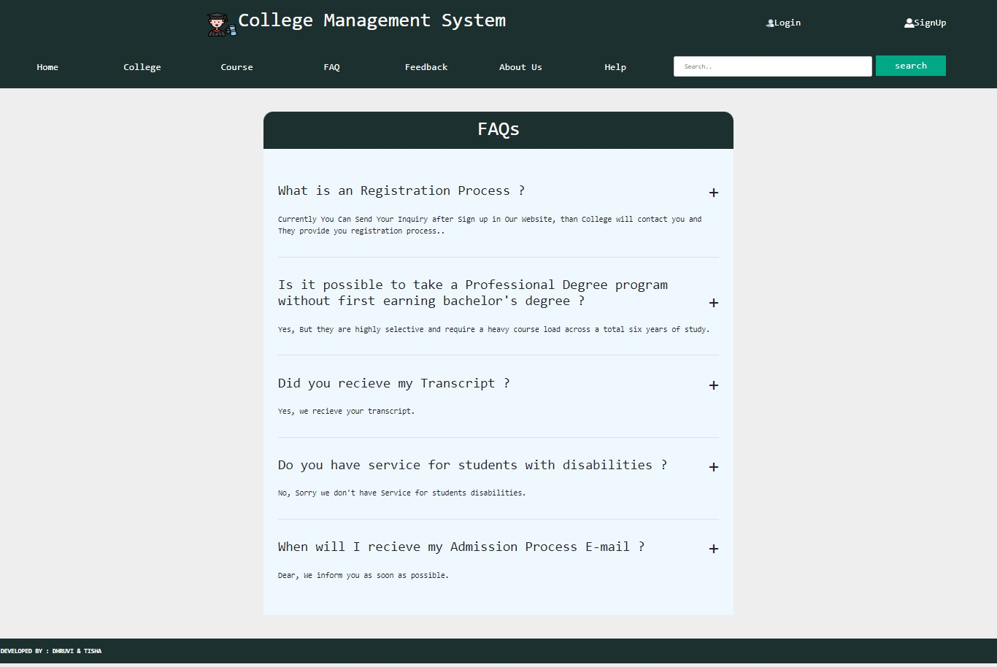

19

Developed by : Your Name
- Feedback Form:
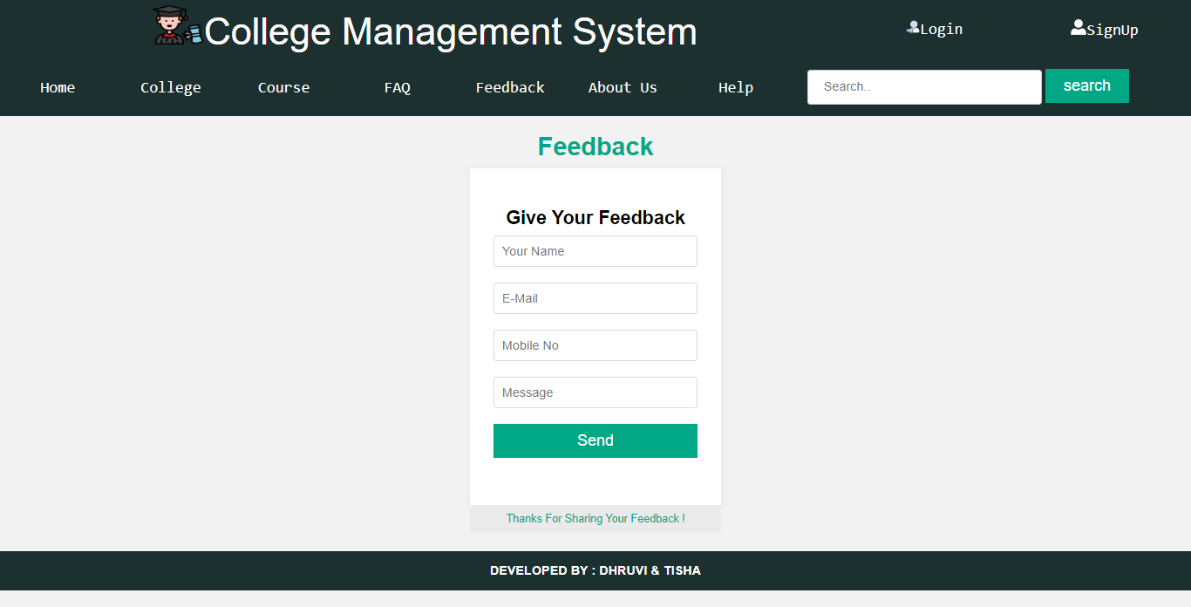

- Show Password Form(if user forgot password):
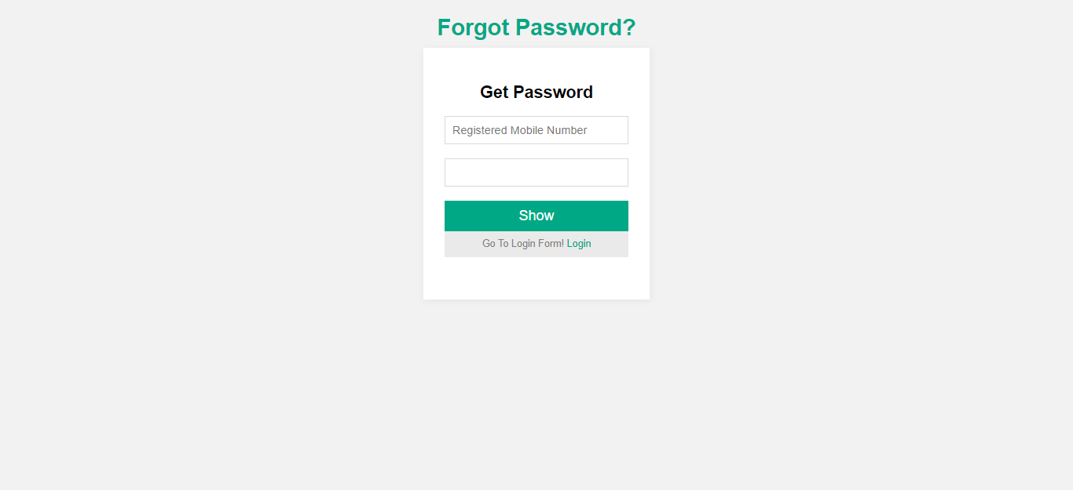

20

- Help page (Contact us page):
Developed by : Your Name
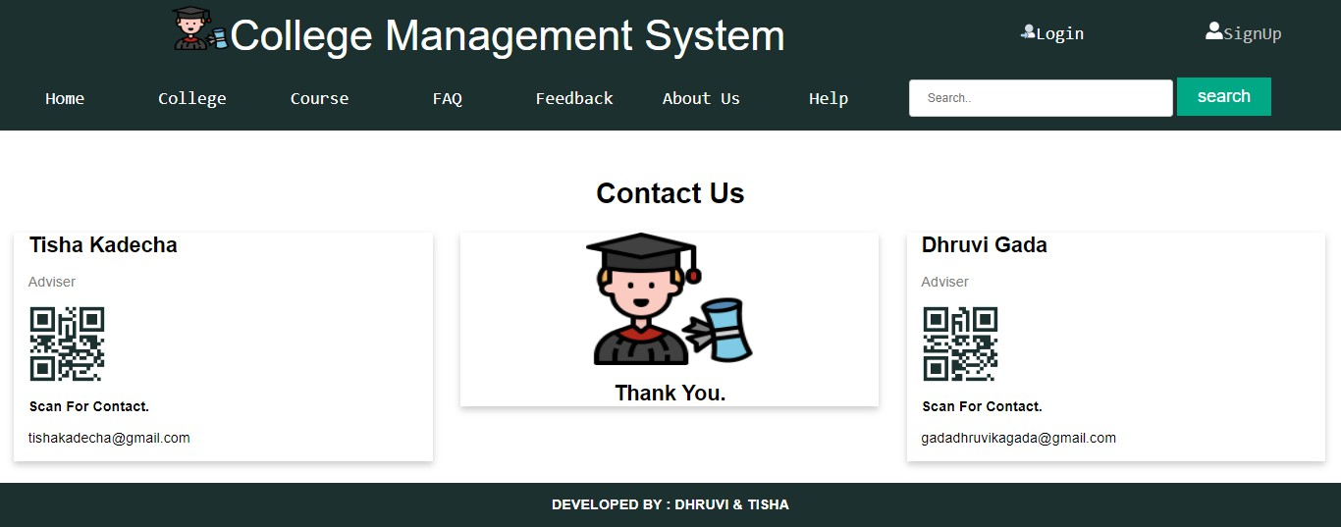

21

Developed by : Your Name

FUTURE ENHANCEMENT

A good project is one which never stops developing according to the changing situations and technologies there is a lot of scope of future enhancements.
  - Online Registration For Colleges.
  - User Search History.
  - M.C.Q ForNew Visitor/User.
  - Notifications to users.
  - Change password option for users.

BIBLIOGRAPHY

For the successful working of my project I have referred many sources for the code snippets, logic and tips and tricks from the various books as well as web sites. Most I searched for the required possessions on the google.com search engine.
Web Links:
- W3school
- Bootstrap.com
- Geeksforgeeks.

22

Developed by : Your Name

6.5 – GLOSSARY

Full Form:-
D.F.D. Data Flow Diagram
S.R.S. Software Requirement Specification
C.S.S Cascading Style Sheet
P.E.R.T. Program Evaluation and Review Technique
S.D.L.C Software Development Life Cycle
P.H.P. Personal Home Page / Hypertext Pre-processor
E.R Entity Relationship
My S.Q.L. My Structure Query Language
H.T.M.L. Hyper Text Mark-up Language
XML Extensible Mark-up Language.

23

Developed by : Your Name



24

